**­­**



**User Document**

**CSRI – Identify**

Backend Coding Team

*23 May 2019*

**Team Members:**

Olivia Sherwood

Chun Keung Ng

Shiqi Jin

**Introduction:**

This document outlines the steps a user must take to use the website, this includes the CSRI-Contact.html page and the CSRI-Questionnaire.html page. It details the structure of the backend and how this interacts with the data submitted by the user.

**Contact Page:**

The below image shows the CSRI-Contact.html page. It details four fillable fields that the user must fill in, before submitting. A popup alert will appear if all fields are not filled. This page gives the user the ability to contact the CSRI-Identify team, it asks for Name, Email Address, Subject of the message and a space to include this message.



On the backend side, we look at contact.php. Once the user has filled in all the required fields in the form and submitted it. The webpage will jump to the contact.php page. This page shows that we have set the database code so that when the user submits the form, the form data will send to the database ‘sit302’ into the table called ‘contact’. It specifies to refresh the CSRI-Contact.html page after the data has been submitted



**Questionnaire Page:**

The below image shows the frontend appearance of the CSRI-Questionnaire.html page. As with the contact page, a stipulation is added that all questions must be answered before the user can submit the form. The website will pop up with a window that states all questions must be answered. This assists the user so that all aspects of the NIST Identify controls are given a rating, and the results are not miscalculated.



Looking at the backend of this page, once the user has answered all of the questions and submitted the form. The webpage will jump onto questionnaire.php. Pictured below, the database code allows each response to each question to be posted to the database called ‘sit302’ and to the table called ‘questionnaire’.



**Load database:**

To load up the database, use MAMP to run the server. In preferences, use Web Server and choose the document root as the SIT302_Backend_VER-3.2_22_05_2019 and choose Apache. Under ‘Ports’, choose ‘Set Web & MySQL ports to 80 & 3306’. Then choose ‘Start Servers’. Then navigate to the myphpadmin page.

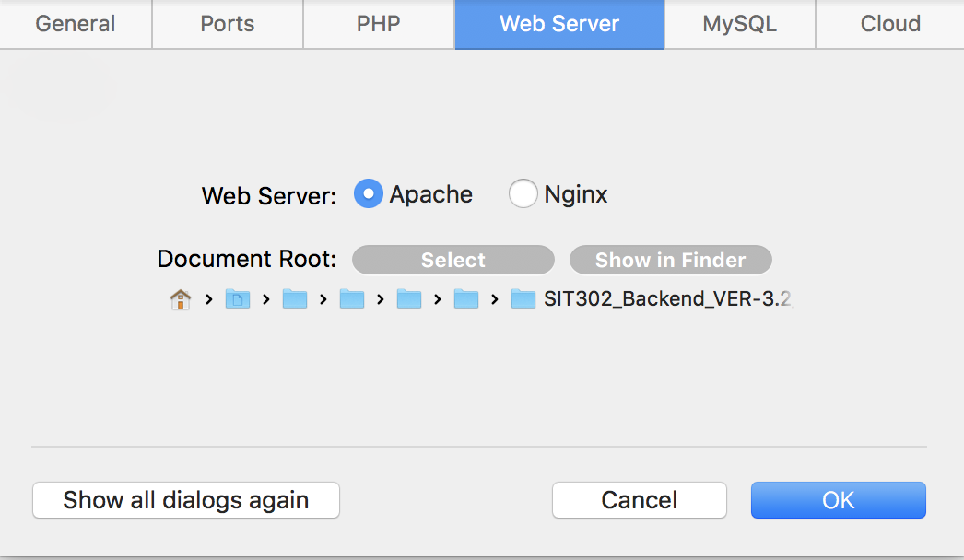

Once on the myphpadmin page, choose the ‘import’ option and upload the ‘--phpMyAdmin_SQL_Dump.txt’ file which will then load in the required ‘sit302’ database.

**--phpMyAdmin_SQL_Dump.txt**

SQL code to create tables in the database ‘sit302’

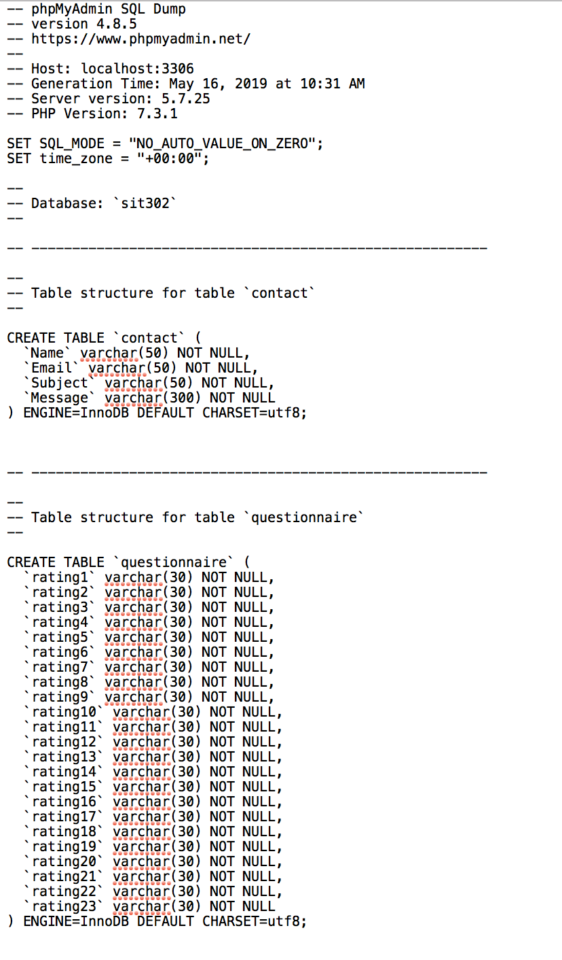

The data location is saved on the local computer (server). On this phpMyAdmin page, the admin can check the input from the user into both tables in the ‘sit302’ database. Additionally, the admin can view the setup of each of these tables and make any necessary changes.





This page is how the SQL code that sets up the database (--phpMyAdmin_SQL_Dump.txt , see below), and can be exported so the same set up can be applied to multiple local machines.

